**Program no. 17 Demonstrate the use of exception handling keyword-try, except ,raise and else.**

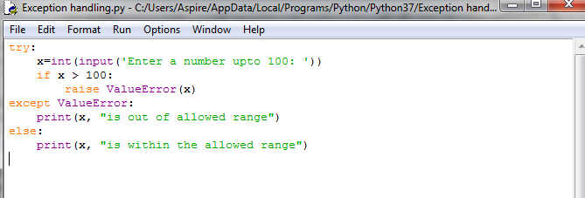

**Output:**

